J.D. Salinger’s The Cather in the Rye to be the NYS 2024
National Book Festival Adult Great Read

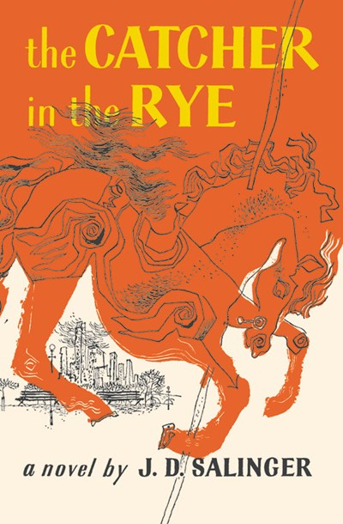

Each year, a list of books representing the literary heritage of the 50 states, the District of Columbia and the U.S. Territories is celebrated by the Library of Congress's Center for the Book during the National Book Festival. Each book is selected by a Center for the Book state affiliate. Books may be written by authors from the state, take place in the state, or celebrate the state’s culture and heritage.

The Empire State Center for the Book has selected the classic The Cather in the Rye by J.D. Salinger to be New York State’s 2024 Adult Great Read selection for the National Book Festival. The festival will take place on Saturday, August 24 in Washington DC.

The novel details two days in the life of 16-year-old Holden Caulfield after he has been expelled from prep school. Confused and disillusioned, Holden searches for truth and rails against the “phoniness” of the adult world.
For additional information contact Rocco Staino, rocco.staino@gmail.com, 914-475-3857

